

Volume x(y): nx-ny
www.ejolts.net
ISSN 2009-1788

Educational Journal of Living Theories

Encouraging the independence of students through the project method

Danijela Ljubac Mec

Danijela Ljubac Mec, mr.sc.
Primary school “Vladimir Nazor”, Slavonski Brod, Croatia

Copyright: © 2015 Ljubac Mec.
This is an open access article distributed under the terms of the Creative Commons Attribution Non-Commercial License, which permits unrestricted non-commercial use, distribution, and reproduction in any medium, provided the original author and source are credited.
Abstract

Pupil’s independence is a necessary condition of the quality of their education. Therefore, it is important to encourage and develop independence in school-pupils. It is necessary to provide experience which supercedes the cognitive aspects of learning and which stimulate the holistic development of pupils. By the encouragement of pupils’ independence, teaching becomes of a higher quality, in that it presumes their greater activity and an engagement with various skills and abilities. Significant learning is grounded mostly on the pupils’ active investigations and projects.
In this work the results of two years of an action research enquiry are presented. It describes the students’ processes of becoming independent through his teaching-project. The main conclusion is that such processes of teaching contribute to the essential learning of the students as well as their teacher.

Keywords: Independence, activity, project approach, liberty, investigation activities, action research, intrinsic motivation, teaching methods, teamwork, cooperative learning

Introduction
A lot has already been written and said about the independence of students in the process of learning, especially in the 20th century when the idea of a new school system, which emphasized that knowledge is not merely transferred through lecture but that students acquire it by individual discourse, was first introduced. The new school representatives' requirements are contained in the motto of Maria Montessori (2004, page 206); ''Help me to do it by myself!''
In contemporary theoretical approaches to learning, constructivism holds a particularly important place. Palekčić (2002) argues that instead of the traditional paradigm of teaching, contemporary didactics advocate the paradigm of a constructivist way of learning which puts an emphasis on the student's individual work. The basic characteristics of the constructivist approach in learning are: active ways of learning, such as learning through discovery; a situational manner of learning; individualization of the learning process, the lack of objective knowledge, the inability of having comparative evaluation of students' knowledge and minimized role of direct instruction in the classroom. The task teachers have is the preparation of a ''learning environment'' in which students can learn independently.
Unfortunately, in the traditional teaching environment that continues to dominate in Croatian primary schools, teachers usually tend to envision and plan the various activities and learning material they are to use in advance and determine the content which should be learnt by the students. In most cases, lessons aren't designed in a way that would allow students to have an opportunity to ask questions, and there is an even smaller possibility of them getting to the answer by themselves through discovery.
This disrupts the process of realization which, according to Bognar and Matijević (2002), is based on the problems of questions, contradictions, hypotheses, models, a continuation in collecting data, observing, checking the hypothesis, experimentation, problem solving, and ends with solutions, answers, conclusions, as well as new issues. When students ask questions, they lead their own research and make decisions about their activities.
Terhart (2001) states that the frequent complaints are that the school separates learning from everyday life and reduces the integrity of life to the acquisition of knowledge. To overcome such an approach to education, Rogers (1985) advocated teaching that takes the complete personality into account, with all the person's experiences, an opportunity with all the actual trials of learning that combines logic and intuition, intellect and emotions. He thought that when we learn in this way, we become whole people who use all their potential. Today, the importance of providing students experiences that go beyond intellectual learning and promote the integral development is increasingly emphasized. In addition, due to the constant changes in society, it is important that students learn to learn independently, do creative work and manage their future (Dryden, 2001, p.107).
One of the possibilities to overcome traditional teaching is found in active learning techniques and processes (Sekulić Majurec, Cvetković & Lay, 1998). The ideas of active learning are not new in educational theory. They can be found, for example, in Dewey (1910), who held that education should be based on children's interests and independent activities. To enliven the idea of active learning, Kilpatrick (1929) designed the project method in which students learn independently by drawing up and implementing projects. This action research is an attempt to improve teaching practices using the project method.

The Methodology of Research
McNiff and Whitehead (2009, p. 11) argue that action research is a systematic study to improve social conditions and publish the results. Action research is mainly carried out by practitioners who are interested in improving their practice. In the context of institutional education, those people are teachers, principals and counsellors (Miles, 2000) and administrators. As my intention was to improve teaching practice, for which I was in charge, I chose action research as an appropriate methodological approach. McNiff and Whitehead (2002) argued that action research is a type of reflective practice in which practitioners question if what is done is in accordance with their values. If we believe that our practice is satisfactory, we should be able to explain and substantiate our claims with evidence. Action research is becoming an increasingly popular form of professional learning (McNiff & Whitehead, 2006, p.7). In the context of schooling, it can contribute to the emancipation of professional teachers since they, together with students, seek to explore the process of achieving substantial changes starting from autonomously-elected educational values. It is important that the students should not be told what to do. They decide for themselves what changes will be carried out in conformity with the other participants of the study. Action research can be conducted as individual and as group research.
This research is largely based on the principles of the life-theoretical approach of action research (Whitehead & McNiff, 2006) in which the structure of the action plan is suggested and expressed in the form of the following questions:
- What is my concern?
- Why am I concerned?
- What experiences can I describe to show why I am concerned?
- What can I do about it?
- What will I do about it?
- What kind of data will I gather to show the situation as it unfolds?
- How will I explain my educational influences in learning?
- How will I ensure that any conclusions I come to are reasonably fair and accurate?
- How will I evaluate the validity of the evidence-based account of my learning?
- How will I modify my concerns, ideas and practice in the light of my evaluations? (McNiff and Whitehead, 2006, p. 79).
The above questions have, in a modified form, helped me in planning, but also in the writing of the report at the end of the action research inquiry.
Given that my research was realized in the Croatian educational context, what was important to me were the ideas and experiences of Croatian authors who wrote in relation to action research. Mužić (1999, p. 25-26 ) states that what is specific for action research is that it is carried out by practitioners, which is very flexible, especially in relation to the draft of conducting research, it is not primarily individual, but can be shared and this is essentially an empirical research.
The research I conducted was in compliance with all the features stated by Mužić: The research I have done, I conducted as a school teacher, trying to take into account when planning it the ideas and opportunities of the students. This was mainly individual research, although I worked primarily with teachers from the school I was employed at, but also with other teachers and educators - participants of the project "Network of Learning Communities" from other schools, which was led by Branko Bognar.
Action research provides opportunities for teachers to become the subject of educational research, but also the creator of their own professional training and development, and serves to improve their practice. In this research, I followed the changes that I've tried to accomplish during two school years, trying to understand and describe the processes that have occurred in my students, but also in myself. In doing so, I used mainly qualitative data.
Even though I sought to find out more about the different options that could be applied in the practice in order to make it better while I was at the beginning of the study, the right solution proved to be the one that I developed together with my students and critical friends. Thus, this study is not only the application of the finished model, but a result of personal creativity and the creativity of other participants of this action research as an attempt to affirm an creative approach to science (Bognar, 2008).

The Context of Active Research
I am a teacher in a primary school "Vladimir Nazor" in Slavonski Brod. This school encompasses the main school and five district schools. I conducted the action research inquiry in the Gornja Bebrina branch school in which I was employed from autumn 2004 until September, 2007. Gornja Bebrina is a small village located east of Slavonski Brod along the Sava River with about 140 houses and 500 inhabitants. Most people in this village are employed in agriculture.
I initially held classes in a rural home because the old school building was demolished for the construction of a new school. Conditions were inadequate (Image 1), but for the next school year (2005-2006) we moved to a new building where I had better working conditions (Image 2). The school was well equipped with teaching materials. The branch school students attend first to fourth grade in two combined departments. Departments are generally combined so that the first and third grade students attend school at the same time, which is the same as the second and fourth grades. Sometimes an exception was made to equalize the number of students in combined classes. That's what happened in our case. That is, research was initiated in the combined first and second grade, until at the end of the research when it became a combination of the second and third grade. In first grade, there were three students and in the second there were nine. Classes in the branch school maintain one shift and run from 8.00 am to 12.15 pm. Sometimes, because of the need to maintain the subject of English language as well as elective catechism classes, students would stay until 13.00 pm. Students go to school on foot because they all live in a place where the school is located.

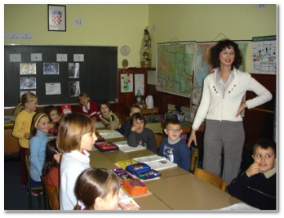
Image 1. Conditions of teaching in a rural home

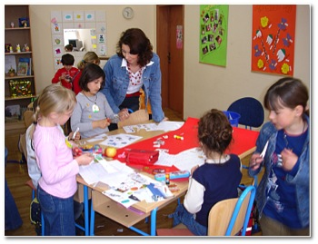
Image 2. Conditions of teaching in a new school

I have become aware of the need for improving the quality of my teaching and I have developed it with an involvement in the "Critical-emancipatory approach to professional development of elementary school teachers" project and "Network of Learning Communities" which were started by the school pedagogue Branko Bognar. During these projects, we have established a learning community held every other Wednesday and in the framework of which we have made ​​more pedagogical topics and became familiar with the concept and realization of the possibilities of action research in teacher practice. Within the project "Network of Learning Communities" we started to use the possibility of collaboration and learning through the internet. Driven by the idea of ​​the importance of lifelong learning, while realizing this project I started a postgraduate study of pedagogy in the context of which this action research inquiry was accomplished.

Why was I interested?
When I was employed at the place of a primary school teacher, the most important thing I had to do was to write a thorough preparation for the lesson, including all educational and training assignments and to prepare everything I was to convey to my students. Careful preparation implied prediction of instructional conversation: my questions and the students' responses, but also what the students could ask me and what I was going to answer them. Although I tried to keep the curriculum thought out in advance, what often happened was that my students tried to take a different direction. I did not allow them because I believed it was important that I stick to my plan. When I first taught the first graders, I began to think differently about children. I began to perceive them as playful and joyful children craving new ventures, rather than as students who were to achieve everything I imagined.
I got the support for such views within the learning community and in the literature that I have read. In fact, I learnt from William Glasser (1994, 1999) that all people have certain needs that they are trying to meet. I recognized these needs in my students. In the process of recognizing the different abilities of students multiple intelligences have certainly helped (Gardner, 1993; Armstrong, 2006). Orientation to the needs of students with different abilities soon found itself in conflict with my "need for a perfect" teaching arrangement that was built on strict methodical pursuit scenarios. It became clear that it was important to let the children share their ideas, thoughts, questions, suggestions, in other words that I do not always have to be the one to dominate. Along with them, I realized that the teacher does not have to be a waxwork located in front of the board, but a warm being whose place is among the students. It became important that students come to and leave school with smiles on their faces.
By observing and listening to pupils I got the impression that they resort to "pulling my sleeve" for every minor detail. Of course, I always like to try and help students in any way possible, but in a combined classroom it is sometimes impossible to devote as much attention to them as they would like me to. I tried to help students to be more self-reliant. Pilić and Tomas (1994) argued that independence is usually seen as a continuous process of forming an autonomous, independent, free and creative personality. According to Anić (1991) independence is the state of one who is autonomous, who is on one's own, independent of the other students, self-reliant. Autonomy is the ability which is developed and implemented by one's own intellectual activity and other students' activity in the long-term educational process, it is also a means of intensive and successful learning, development, self-realization and recognition of students' personality and - the ultimate goal of teaching process, which is a prerequisite for further education and self-education (Koraj, 1990). The students are independent when there is no outer influence on their thinking, words, acts and decisions. My desire was to encourage students' initiative, curiosity, independent setting and solving problems. I tried to wake in them the cheerful children who could not wait to start new ventures. Another important value that I'm trying to establish in my practice is the active learning of the student. Sometimes it seemed that all the activities of the students in my class were nothing more than solving school-related tasks and fulfilling my orders. Recess was the only part of the school day when they were able to get up from their uncomfortable chairs and move freely around the classroom. What constantly followed me was a sense of how students are restrained and that "I hold the reins in my hands" too tightly. So, in late 2004, I decided to call my critical friends Vesna Šimić and Dubravka Matuško to observe my lessons, as well as an educator, Branko Bognar. I asked them to give me some feedback on whether my teaching allows students' independence and activity. I held my lesson in Croatian language in the combined class of first and second graders that Branko filmed with a video camera.
Immediately after school I spoke with my critical friends who have helpfully pointed my dominant role out and recommended that I try to mainly leave to the initiative to the students in activities that may be of interest to them. I subsequently analyzed the recording of the lesson with the help of the program for qualitative analysis (Bognar, 2008) and found that a large percentage of students were guided and missing independent activities (Image 3).
The summary in a video recording of the lesson can be found at http://youtu.be/6vcxeFJ0lxc

Image 3. Analysis of student activities at the initial video clip of the lesson

Based on Flanders' interactive analysis on introductory conversation with students I found that what is predominant is the activity of the teacher (Image 3). Teachers dominate activities concerning questions, presentation and instruction and while I accept or use students' ideas less, I encourage them and accept their opinions (Image 4). Students often answered the questions in unison - in one word or short sentences. In the conversation I was trying to explain to students, by citing the example of Chinese symbols yin and yang, that everything good has a bit of bad in it, and that in any accident there can be a bit of luck. A critical friend, Branko Bognar, when examining the video, wrote the following comment:
Although the discussion was related to the topic of the text from a textbook that you were intending to read, one could get the impression that this issue was quite abstract for the students, and they were trying to guess what you expected them to say, instead of having had a chance to talk about their experiences and ideas (B. Bognar, personal communication, December 2004).

Image 4: The ratio of teacher's and students' speech

Image 5 : Analysis of the teacher's actives in the initial video of the lesson

After an introductory conversation I read the text entitled "Blessing in disguise" from a textbook to my students and then had the students read excerpts from the same text. My critical friends have pointed out the problematic nature of such a methodological scenario. The purpose of reading is to learn something new, and re-reading the same text can lead to boredom rather than spark an interest for reading in students. I then gave out some proverbs written on worksheets that the students were supposed to read, then explained to them in pairs and wrote their meaning, and in the end they were supposed to think of a few proverbs themselves. The footage shows how very few students consulted each other during the execution of the task. Some of the students looked around confused, and some asked me about what they should do. Although all pairs achieved what I predicted I found that neither the students' activity nor their enthusiasm for the activities that I thought of were particularly significant. Only at the end of the class smiles appeared on the children's faces, when I told them to play music on the children's CD player and they all danced with delight.

Image 6: Results of parents' responses to the question of the independence of their children.

Image 7: Results of parents' responses to the question of their childrens' cooperation.
Before the start of the action research, I had done a survey with students and parents trying to retrieve feedback on the fulfillment of the basic requirements in my classroom. Students' responses to the questions regarding independence showed me how almost all of the students, except one, do not consider themselves independent enough in school. Most of the students in the survey state that they do not cooperate enough with other students in the class. However, to the question of whether they are satisfied with the current state at school all the students have responded positively.
Parents had also been asked to fill in a short questionnaire (Appendix 2) on autonomy, the right choices in school, collaboration and obligations of children at home. To the question "Do you think your child is self- sufficient?" Most parents responded that their children are not sufficiently independent (Image 6). Also, most parents (8) state that students do not have the right to make choices in school. However, most of them stated that their children cooperate with other children from the class (Image 7). On the question of "business" of students with school obligations at home, opinions are divided. There are more who believe that students are not sufficiently busy with school commitments at home (7 parents), compared to those who disagree with it (5 parents).
The analysis of the initial recording of the lesson and the results of the questionnaire showed me that there was plenty of room for the improvement of baseline values: independence, activity, and cooperation. I had the need to set myself and my students free in order to enable them to feel more engaged at school and allow them to actively contribute to the class. Due to the long time I spent searching for what would really encourage the children to a higher level of activity and independence, I realized that the project method could be one of the answers to the realization of my, then quite neglected, values​.

What could I have done?
In developing the project method, Dewey's ideas play a particularly important role as they are ideas which represent a key element in upbringing children for life in a democratic society. Democracy should not be seen merely as a form of governance, but it is a way of living together in which people seek to align their interests with other members of the community. (Dewey, 2004, pp. 93-94)
Influenced by Dewey's ideas about education for democracy, Kilpatrick introduces the concept of "the project method". By the term "Project" he means the purposeful activity that is an integral part of life of dignity in a democratic society because, according to him, the project method should be an integral part of the course that is not just a preparation for life, but life itself (Kilpatrick, 1929). Project or purposeful action is therefore planned activity in which students strive to meet their needs and interests and to achieve the set goals autonomously. To make this possible, it is important to teach children to think independently.
The activity of students in the realization of the projects is based on their interests and abilities. Helm and Katz (200) emphasize the importance of the student's initiative, involvement and relative control of their activities. Students independently plan, generate ideas, mutually agree, and solve problems they encounter in the learning process. Teaching often takes place outside the classroom so students are able to apply the acquired skills in life situations. If there is a failure in the implementation of the project, they start from the beginning together. In addition to planning, programming and implementation of activities, students participate in the evaluation of the project and thus become active participants in learning at all stages of the teaching process. They learn independently, acquire new knowledge, review the set goal and choose strategies to achieve it (Peko & Borić, 2001).
The project method is difficult to achieve in a classroom where the teacher dominates. It is so in teaching where the structure consists of the following stages: preparation, processing of the course content, practicing, repetition and checking (Poljak, 1980), in which the teacher plays the dominant role, and it is difficult to realize the project aims. However, Bognar and Matijević (2002) perceive the educational process as a joint activity of teachers and students, and therefore claim that basic stages of the educational process are: agreement, implementation and evaluation. In such a structured educational process the project method can easily find its place.
Munjiza, Peko and Sablić (2007, pp. 49-51) believe that the students' projects can be accomplished in three phases: preparation, realization and reflection:
- Preparing a project involves finding a topic, formulating the objectives and planning project activities:
a. Finding a theme. The students select a theme according to its relevance or the need for it, but also according to the Curriculum. It can be reached by democratic means, meaning that each student proposes a topic they would like to be addressed. In doing so, one can use the creative technique of "brainstorming". When questioning the proposed topics, students can be divided into groups to choose topics of their projects.
b. Formulating objectives. In formulating the goals of the project courses, it is important to keep in mind exactly what we want to achieve, how we want to achieve it, and how we will present it to the public.
c. Planning and preparation of project activities. Planning is first implemented as a draft, and later in detail. All that matters should be recorded and placed in the project folder also known as the portfolio. The portfolio is a collection of works students choose themselves and through which they can present their work, interests, motivation, achievements and progress in one or more areas of schooling (Španović, 2002).
- Realization of the project refers to the pupils' collecting, processing, analyzing, systematizing data. Helm and Katz (2001) argue that the realization of the project may include parents and experts providing students with the necessary information and resources related to topics they deal with. At the end of this stage, students present their projects. There are different forms of presentation. Students can create a flyer, poster, brochure, broadcast by radio, or a video, etc. Then the students and teachers open up new questions that can act as a basis for the next project.
- Reflection on the project. The critical reflection on the overall progress of the project follows after the presentation of results. Here we should critically look at the things that were right, but also amiss, and there may be proposals about what could be performed in the future attempts. Cooperation is also discussed, in teams. In this section we utilize the project folders that allow us to have a detailed analysis of the project.

After the accomplishment of each project, students can relax and take a break until the next project. By accomplishing projects we enable the students to become aware of their own possibilities for action (Lesourne, 1993, p. 221).

What was I planning to do?
Before the start of the trial, in accordance with the Code of Ethics of research with children (Ajduković & Kolesarić, 2003), I asked the parents’ permission to photograph and record the students and lessons with a video camera. All parents gave their written consent to the recording of the teaching activities.
Before the start of the research I examined the interests of students in the survey (Appendix 1) and based on that I developed a draft of the plan of research. I read and explained the questions that I was not sure all the students understood, and they checked the multiple choice answers independently This was done in the light of the fact that the survey was conducted in the second half of the year when all first grade students had learned to write, although not all of them were equally successfully. By this questionnaire I wanted to determine whether the students wanted to participate in project activities and what the areas of their interest were.
When asked whether they wanted to engage in research in the school they answered affirmatively. Students had a choice of three courses within which they could do their research. They all decided to research within the subject of nature and society. Then they had to specify what they want to explore inside of the course. They all decided to explore animals and plants. Students individually named one or multiple ways in which they could execute their projects. Some answers were repeated. Most of them voted for collecting data from the encyclopedia (7 students). Somewhat less wanted to work on the internet (6 students), observing animals (5 students), observing plants (4 students), a walk through the meadow (3 students), pressing plants (two students). One student each said that they would like to read interesting facts, take care of the animals, describe, paint, write poems, draw frames, visit the zoo and play with the animals. Based on the results of the survey, we determined the possible themes of projects the students could engage in. Since it was winter period, we first focused on researching animals, and later on another project, about the plants. What followed then were other projects: Healthy Eating, Little meteorologists, Creating a student journal, Water, Winter and Cats.
As we realized the research, I adapted and modified the research plan and some parts of the plan emerged during the research. Specifically, as topics of student projects are selected through democratic means, it would not be good to devise them beforehand and then present them to the children. Of course, it disables the detailed planning which is not necessarily required in action research, because the planning process lasts during the entire trial, and includes the other participants, especially the students. The plan shown in Table 1 was emerging then, during the trial which lasted from March, 2005 to March, 2006.
Table 1. The plan for action research
Planned activities | Criteria | Data
Student project: Researching domesticated animals (March and April, 2005.)
- The students' observation and study of domestic animals, finding texts and interviews with older people who are engaged in work with domestic animals  - Editing of the student portfolios, wall posters and the classroom magazine on the Internet (blog)  - Taking pictures and recording video clips of animals  - Creating a classroom newspaper as well as wall posters with researched animals | - Students independently observe farm animals and take notes  - Students know the basic facts about farm animals  - Students write their own texts and involve them in portfolios and post them on the class blog  - Students choose what will be presented on the poster | The students' portfolios, photos, videos, my research journal, the class blog, the class newspaper "Beturel" and the classroom poster, a survey with students
Student project: Healthy eating (May and June, 2005.)
- The division of students by teams. Each team studies a particular type of food  - Thematic posters of a healthy diet  - Creating "summer refreshments" - lemonade, ice cream and fruit salads | - Students recognize the different types of foods and distinguish healthy from unhealthy  - Students negotiate and prepare a menu of healthy eating in teams  - Independently they prepare drinks and simple meals | Video recordings of the lesson, the conversation with the shopkeeper, baker, milkman, critical notes from my friends Branko Bognar and Lidia Udovčić, a research journal, a wall poster, Evaluation papers, recordings on the blog, surveys with students
Student project: Plants (June, 2005.)
- Students are divided into three teams to study flowers, trees and mushrooms  - Each team makes a real magazine about their topic  - Creativity in students - making little houses in flowers | - Students are able to write themed texts using literature and the Internet  - The class newspaper published at least ten written texts and some pictures related to the topic  - Students can independently arrange and create a model home with a veneer of flowers, moss, moldings, ivy and natural materials | The students' papers and magazines, and records on the blog, a research journal, video and photography of the classes, surveys with students, notes the from my critical friend Dubravka Matuško
Student project: Little meteorologists (September, October and December, 2005.)
- Students write down everything they know about the weather, and at home they read and find out more information  - Visits to the meteorological station  - Creating the class paper "Rain Sheet"  - Making Meteorological posters | - Students independently write texts about weather conditions  - Students know how to name and specify the devices used by meteorologists  - Students make the class paper | The records of students at school and at home, the texts on the blog, class papers, research diary, videos and photographs of classes, a research journal
Student project: Creating the student magazine (December, 2005.)
Creating the student magazine | - The pupils, divided into teams, create their own magazine.  - Students take on the roles of writers, illustrators, editors and prepress | Video footage and photographs of the teaching, the pupils' magazine "Little Worker", notes from critical friends - 4th year of university students, research diary
Student projects: Water, Winter, Cats (January and February, 2006.)
Individual team projects | Students independently devise and implement their projects | Videos, a research journal, published student works on a blog, student forms for the plan of the project, tracking and inventory of the students' activities, students' evaluation papers, notes from my critical friends Vesna Šimić and Dubravka Matuško

I collected the data for the research in different ways: through videos, photographs, notes from critical friends, evaluation sheets, interviews and surveys. During the research I conducted a research journal, and I published some excerpts from it on a domain for online collaboration so that the rest of the participants engaged in the exercise of action research could send their comments.
In action research, my critical friends, who help me in achieving the quality of my research, play a significant role. In our context professional staff can take this role, especially pedagogues (Bognar, 2006a). Lomax, Woodward and Parker (1996) see the critical friend as a confidant or mentor who is assumed to be well acquainted with the research context and regularly talks with the action researcher on the course of pursuing their research. The reflection of critical friends, in terms of helping action researchers in data collection, consultation on possible solutions to the identified problems, providing feedback on teaching practice as well as psychological support to action researchers, especially during the crisis period in the realization of the planned changes, is also very significant. My critical friends were Branko Bognar, then a pedagogue in our school, and now an assistant at the Faculty of Philosophy in Osijek; Dubravka Matuško, a teacher; Vesna Šimić and Lidia Udovčić who worked in the neighboring regional schools. When I asked Branko Bognar to be my critical friend, he told me that they would agree to it only if I were willing to listen to his critical comments. True, it was not easy just to accept this request, but I still said yes because I was aware that it was an important precondition for improving educational practice.
In addition to critical friends, I had a validation group, which consisted of the participants of the project "Network of Learning". McNiff and Whitehead (2002) argue that the validation group should give researchers feedback on their research. In the validation group, we tried to answer the following questions:
• Is the report a valid description of the educational process?
• Are the claims supported by sufficient evidence - data?
• Is it enough to clarify what the significance of peaks in practice is? (McNiff & Whitehead, 2002, p. 105).
• Is the value of a constant effort of achieving present?
• Are changes noticeable?
• Have important changes in practice been achieved?
• Is the self-critical approach apparent?
In addition to the validation of critical friends and the validation group, part of my master's thesis was conducted and academic validation with respect to this research. Members of the committee for the defense of the master's thesis consisted of the academic validation group.

What did I do?
Project: A study of domesticated animals
One of the features of the design method is that connects with the students' research. The essence of such research activities is that to gain the information, the student must not only memorize and reproduce it, but to come up with it on their own- by research, or, if necessary, with the help of teachers (Munjiza, Peko, & Sablić, 2007). The students' research starts from their questions, for which there are no simple answers. In this method, teachers should try to avoid giving ready-made answers, but should instead encourage students to set more questions to come to said answers.
Students began to explore systematically by observing animals, and later some of them wrote about it. Some students do this all very seriously. They were full of questions and suggestions, while others were waiting for me to tell them exactly what they had to do. After a while, all the students started collecting written and pictorial information about their animals. The texts were recorded on individual sheets of A4 which kept in special student folders - portfolios (Image 8). These folders eventually became increasingly richer, and the students were proud to take them home.
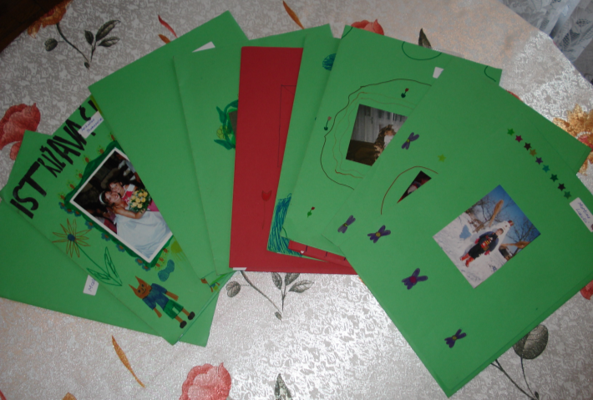
Image 8. Student portfolios

The students who had no idea where to collect the materials because they did not have any pets turned to me for help. I brought several encyclopedias and magazines about animals from the main school, so we spent the homeroom class looking for the information they needed. It could then be seen who was already an independent data- collector of data. In addition to reading encyclopedias and other books, the students were looking for information on the Internet. Since most of them did not have a computer at home, and therefore no access to the Internet, they sought the help of neighbors.
In the study of animals, the students collaborated with members of their families who had noticed that the children were “bright and shining” and that something beautiful was beginning to happen. Once they had gathered enough information and notes about the animals, they wrote short articles that are posted on their class e-magazine "BETUREL." Because their folders contained a multitude of texts and materials, they needed to single out the most important data and assemble quality texts that would be the result of their research. Therefore I often had to assist them in the preparation of short texts, taking into account that they themselves choose what they should write about. After the first text was completed, I put it up on the internet because the students did not yet know how to do it themselves. Students were happy to know that their words could be read outside our classroom, and even outside the village. After some time, they taught themselves to publish their work on the class blog and apparently did so happily. In particular, they rejoiced at the comments of readers which were almost always positive. Occasionally they had technical difficulties with the computer, but were able to solve them with the help of parents.
At the beginning of each week, we talked about whose family farm we wanted to visit to photograph and record video clips of animals (Image 9). The students were very independent in the organization of the visits. I recorded how one of the visits went in the research journal that I regularly conducted. I published some notes on the system for e – learning, Moodle, that we used in the project "Network of Learning''.
"Another beautiful day, but completely different from the previous one. Specifically, I described earlier that every student was studying one animal that they have at home, by their own choice. So far, the students have recorded some data and stored it in folders (portfolios) contained in the classroom.
Today after school we went to take video clips and photographs of animals for some students. First we visited N.D., who studies ducks. The ducks were quite excited when they saw us. We were all surprised when we saw how big duck eggs are. We learned something new! - Do you know who is sitting on duck eggs? The mother! Now we have to be patient for a few days, and then we'll come back to visit the young ducklings.
Then we visited M. L., who studies sheep. And here we waited for a big surprise! Among the sheep was a little lamb that had come into the world that day! We were surprised that it already saw and walked. True, its legs were occasionally wobbly, like a little Bambi on ice. Martina showed us how brave she is and went among the sheep to feed them corn.'' (Ljubac Mec, personal communication, April 6, 2005).
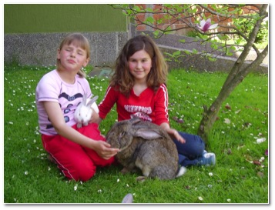
Image 9. Students with the animals they studied
At the end of the project, the students completed a questionnaire in which they expressed their satisfaction and evaluated the activities, independence and cooperation, and noted the sources used (Appendix 3). My satisfaction survey assessed the 5th grade students and stated that the study of animals had become more independent and active.

Table 2. The student's sources of information during research
 | Internet | Encyclopedias | Magazines | Talking to professionals | Observing the environment
Number of students | 3 | 12 | 10 | 11 | 11
Percentage | 25 % | 100 % | 83,3 % | 91,6 % | 91,6 %

Students used various sources of information. All the students utilized encyclopedias. The first graders initially had extra help from their parents, and later on at the end of the year they found texts on which they worked by themselves. Most of them talked with the experts. Many observed phenomena in their environment, while the lowest number of students used the Internet (Table 2).
Table 3. The assertion of students on collaboration with colleagues
 | Not at all | A little | A lot
Number of students | 0 | 4 | 8
Percentage | 0 % | 33,4 % | 66,6 %

Most of the students (8) chose the answer "a lot" when asked how they collaborated with other students from the class during the study. A small part of them said that they collaborated a little, but no one said they had not collaborated at all (Table 3). Despite the students' responses to the questionnaire I noticed that the students accomplished most activities individually, rather than in collaboration with other students. Therefore, I decided to try to improve their cooperation.

Project: Healthy eating
After the completion of the first project in which the emphasis was on the study of animals, the students expressed a desire for a new theme and a new project. As we continued to work in the Nature and Society class that dealt with the amenities for healthy eating, students suggested it as a theme for our next project. I accepted suggestions from Helm and Katz (2001) that the pupils' prior knowledge was to be displayed in the form of a mind map to encourage them to formulate questions that are important to their trial in order to define the area of their interest.
Students individually divided into teams and decided which part of the diet deal will be theirs. They agreed on which facilities in the country they would visit: the bakery, the dairy, the local shop, to gather as much information about food products. The team members who had decided to visit a bakery talked with workers and learnt how to make bread. In addition, they made a list of products made of flour so they would be able to report it to other teams. When visiting the store, students made separate lists: fish and fish products, meat and meat products, dairy products, flour products, sweets and fruits and vegetables. In addition, they collected a multitude of written and pictorial material on foods from different magazines, encyclopedias, and the Internet. Upon returning to school, teams submitted a report on how they did. The team's task was to create posters with several menus and show their importance to our health. At the end of the class, teams evaluated each other.
Branko Bognar visited us for the lesson. He systematically studied the activity of a team and talked to them after school. Although the students did not notice problems in their cooperation, they stated that student N. was the boss of the team. In our conversation, Branko warned me about the problem of the domination of student N. who spent more time talking to me than to the members of her group. At that time I felt it was part of her personality and that there was nothing I could do, "I think it will always be so. Things can be arranged, but when you have a very dominant person, then it is as it is. She can learn some rules, but that is a part of her personality that comes to the fore" (Ljubac Mec, personal communication, 28 April 2005). Branko asked me what I could do about it. I answered as follows:
Danijela: Well, I am constantly trying. Whenever she came to me for information I never gave her any, sometimes I led her to the answer, but I always told her, "Go back and try to negotiate with your team!" I react in that way.
Branko: That was once.
Danijela: Once!? There, perhaps even I'm not even aware of it.
Branko: It was once, I have just realized, you told her once: Bargain! And really ... At that moment the communication between them began, but in most cases you actually still gave them answers: Good. Do it! Here put this here!
Danijela: I was not even aware of that...
Branko suggested to me that I should let the students attempt to reach an agreement, and to interfere less in their activity. On my comment that N. was again likely to dominate, Branko said that she was dominant and that she tried to alter my comments, even the neutral ones and managed to turn them into affirmations of her ideas which were to be realized by the other members of the group. After I analyzed the recordings of teaching, I realized the same thing. I concluded that it is necessary to work on collaborative learning. I decided to redirect student N.'s dominance into something positive that can contribute to the learning of all students. I managed to make this happen in the project A Small Printing House.
After some time, the students learned something new about the contents of a healthy diet. Finally, they had to make something for themselves. They decided to make Summer refreshments: fruit salad, ice cream and strawberry lemonade. These activities were recorded in teams as well thus far. A critical friend, Lidija Udovčić, attended the class and found that it had a pleasant working environment and good cooperation between the students: "The atmosphere is pleasant and busy. Delight at the time when they need to do refreshments (ice cream, lemonade and fruit salad). Teams cooperate beautifully. The culmination of emotion is at the end of the class when students enjoy the Summer refreshments. " (Udovčić, personal communication, June 2005).
Students have learned to handle an electric mixer, chop the fruit, make ice cream and fruit salad, lemonade, and realized their importance to our body. At the end of the class they expressed their thoughts in the evaluation slip (Image 10). Students were pleased and happy to have had the opportunity to independently prepare some dishes and drinks that were eventually eaten and drank together (http://youtu.be/ryfUdtJc2A4).
(Image 10) I LIKED: I liked when we made ice-cream and when we chopped up strawberries. The team worked very well, and I was very happy.
I DISLIKED: When the teacher said we must wait until Friday to eat the ice-cream.
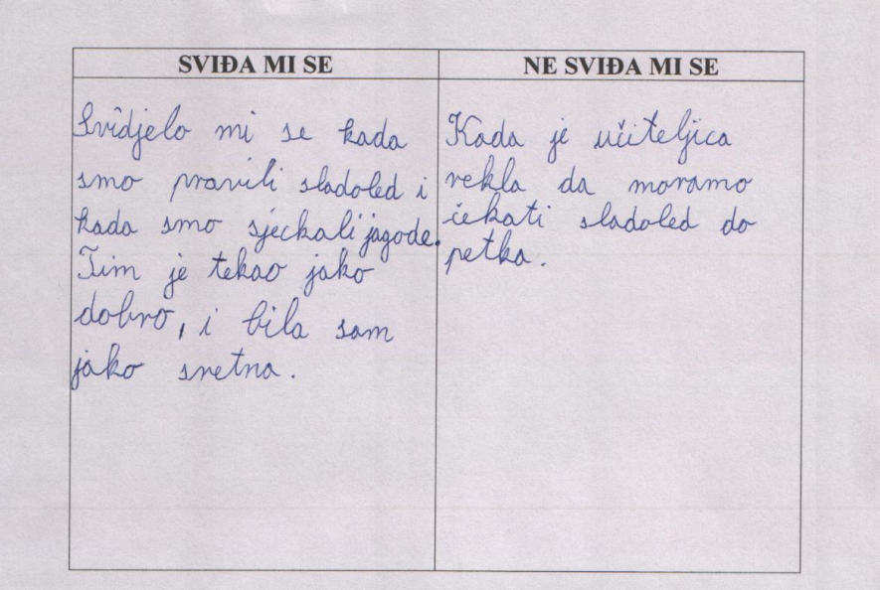
Image 10. An example of the student's evaluation slip

Project: Plants – mushrooms, flowers and trees

After receiving feedback that the students wanted to continue to engage in research, I offered them the possibility to choose themes again. Unanimously, they decided that they would deal with the study of plants: mushrooms, flowers and trees. Independently, they elected activities through which they wanted to realize their projects. The only prerequisite was that they adhere to the selected theme.

The project teams collected texts and frames from different sources: the Internet, professional journals, old books, etc. They looked at the trees in the village, asked older locals about the names of plants, and made lists. One group crafted a herbarium of the collected plants, while others drew flowers. Among the drawings were also the unusual flowers from the children's imagination.

In order to realize the practical part of their project, the students brought a multitude of collected material: flowers, leaves, moss, veneer, cardboard, a hammer, a saw, nails and tempera to school. In the beginning, each team realized its practical task: a mushroom house and a flower meadow. However, in the end they agreed that all they want to unite in a common work . This created a "cottage with trees , flowers and magic mushrooms " (Image 11, http://vimeo.com/2722890).

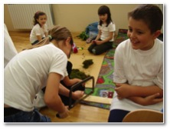 | 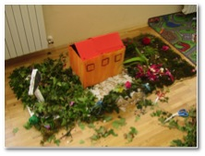
Image 11. Pupils' creative activities within the project about plants

I called my critical friend Dubravka Matuško to the class and she expressed satisfaction with what she saw during the visit:
The teams combine their projects. They all try hard in the final design of the interior. This kind of teaching is quality teaching because students are responsible for the project. In the process of learning, they gain new experiences, encounter some of the tools used by their parents. On the basis of trial and errors they find new and better solutions, and thus express imagination and creativity. They are independent in operation. The teacher is an observer and coordinator of activities (Matuško, personal communication, June 2006).
During this project, students collected textual materials from which they made ​​a magazine about each of the topics they dealt with. Although I helped the students in the making of the magazine, they now have more experience and their ideas came more easily. I finished the computing and networking​​ myself, but then I decided that I would refer to the main school in Slavonski Brod to bring binders and teach students to fill them with the magazine.

Project: Little metereologists
We started the new academic year with a new project. Then the participants were already second and third graders who had more experience in project lessons. Therefore, we started with the realization of the projects at the beginning of the year. Since almost all of those days were rainy, the students decided to be little meteorologists.
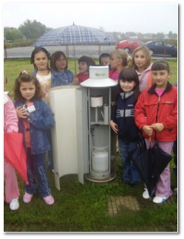
Image 12. Students visiting the meteorological station
One of the major project activities was the visit to the Meteorological Station, where the students encountered this kind of measuring instruments for the first time (Image 12). In the research journal, I wrote the following note about the visit:
Like many previous days, this day was rainy. But that did not stop us in our intention to visit the weather station in Slavonski Brod. We hired a couple of parents who drove us there. We were greeted by a friendly gentleman who acquainted us with his job. The students were in awe when seeing meteorological measuring instruments. After long and fairly technical presentations, the students had quite a few theories. So we asked the meteorologist to allow us to try some measuring ourselves. Of course, the students, like real explorers, rolled up their sleeves and went into action. They measured the amount of rainfall, soil temperature, water temperature, air pressure... It was their real little adventure! (Ljubac Mec, personal communication, October, 2005)
The visit to the meteorological station was an incentive for students to continue independently to measure rainfall at home and at school (Image 13). After a few weeks of active with regard to monitoring weather changes, we created a new class magazine "Rainy Sheet", as well as meteorological poster.
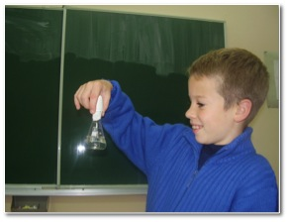
Image 13. The student brings collected rainwater to school

Project: The little printing house
Since the students had created several magazines whilst working on projects, they came up with the idea of starting a new project "Small printing house." This time the target was to create a magazine together as soon as possible. All the students were one big team. This project was realized within the Croatian Language class. First, I informed them on how magazines in Croatian are produced. After that, according to their abilities and inclinations, we formed the following groups: journalists, illustrators, editors, and prepress. In that project, we strived to reveal the personality of pupils in a positive way. N. very successfully took over the role of the editor of the magazine. In this way it was possible to demonstrate her leadership skills and her advice contributed to the objectives of the entire group.
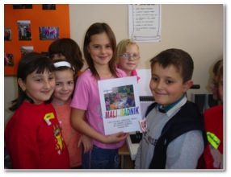
Image 14. Pride and happiness on the students' faces after they made the “Little worker “magazine

During two consecutive lessons, students, led by the editor in collaboration with the technical editor of the magazine, created and democratically chose the name "Little worker." We are extremely proud of their work because they showed how independent, active, hardworking and creative (Image 14) they are. They were trained the craft of self-assembling texts, illustration, typing on the computer, taking pictures, transferring photos to the computer, setting the image on the cover, printing the cover and binding newspapers on the machine for binding (http://vimeo.com/2722525).

Project: Cats, Winter and water
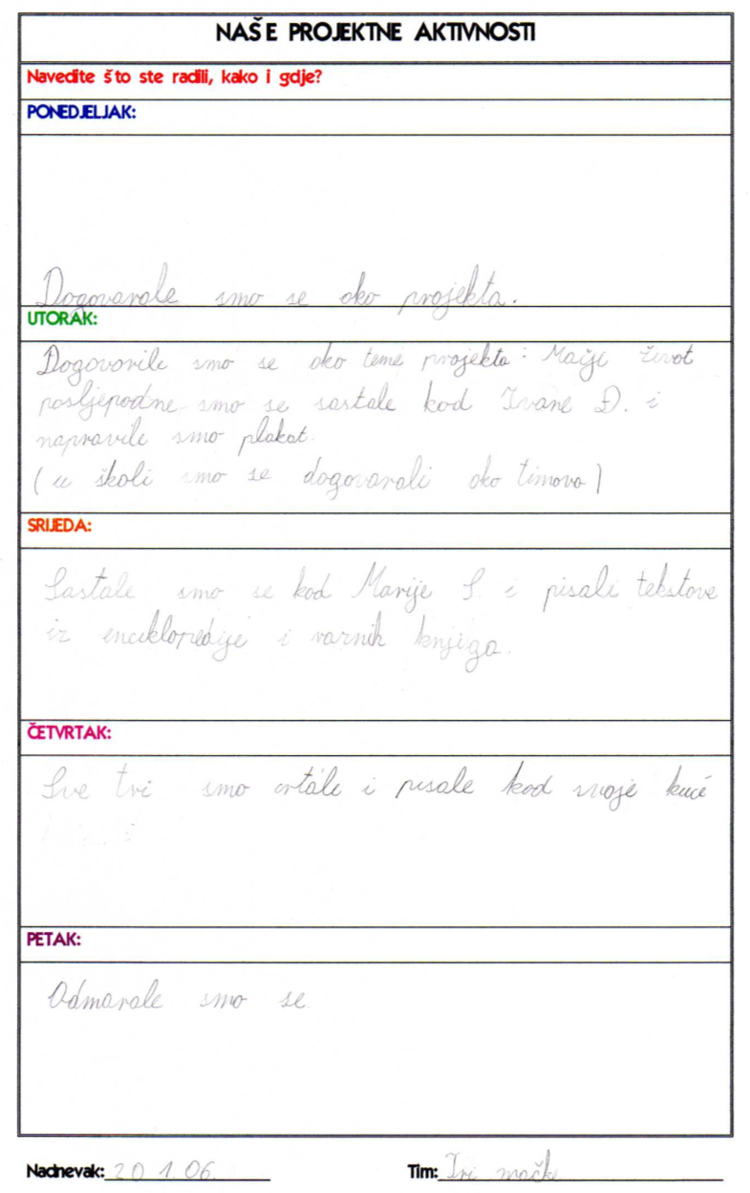

OUR PROJECT ACTIVITIES:
State what you were doing, how and when?
MONDAY: ''We were discussing the project. ''
TUESDAY: ''We agreed on the topic of the project: The life of cats. In the afternoon, we met up at Ivana Đ.'s and made a poster. (at school, we had arranged teams)''
WEDNESDAY: ''We met up at Marija S.'s and wrote texts from the encyclopedia and other various books.''
THURSDAY: ''All three of us wrote and drew at home.''
FRIDAY: ''We had a rest.''
Date: 20.1.2006. Team: Three cats
Image 15. The diary of project activities
We devoted the next six months to the study of cats, winter and water as much as we could fit in the programmed structure of the Nature and Society class. These were three different projects that the students conducted simultaneously. Students individually selected topics, depending on their interests. At the same time they formed the teams themselves. To help students to comply with the default theme better, I prepared forms (Munjiza, Peko, & Sablić, 2007, p. 129) that each team should have filled. Teams had more concrete goals, tasks, and ways in which to reach their goal. Additionally, they received forms in which they kept a diary of the project activities (Image 15).
Each team chose their activities. The team that studied the water collected extensive information about water and its importance to people. They decided to include it in the class newspaper so others could later benefit from the texts. In addition, they created a scale model of a farm yard where a well is the only way to acquire water.
Another team that dealt with the theme of Winter also collected textual materials. Some of the texts were published in the class e-journal. Together they created a poster about the selected theme for the presentation. The poster presented the main features of Winter, but it was also rich in poetry and prose (Image 16).
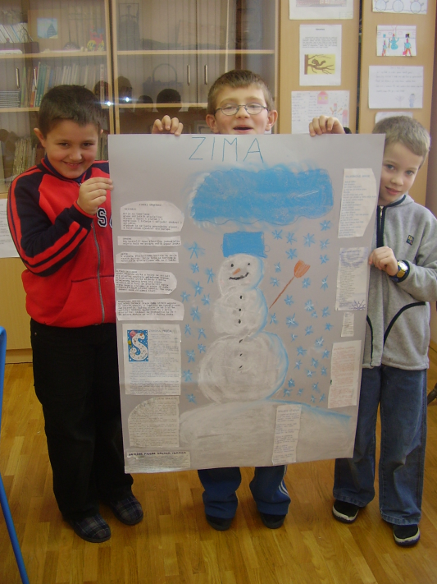
Image 16. Poster ''Winter''

The third team, the students who decided to study cats, love animals very much. They met at their homes and researched together. In addition to the observation and monitoring, in books they found the information they did not previously know. Their care for the animal showed in the presentation of the project and by the fact that they made a warm bed for the animal and containers for the animal's food from modeling clay and sewing cotton bedding for the crib.
During the week, each team reported to others about what they have learned. Students were further motivated to listen because they had agreed to have a quiz at the end of the week that included all of the information set forth during the week. The team which compiled the most correct answers won the grand prize, which was a stuffed dog that was purchased with money from the class savings.
By accomplishing these three projects, students showed a remarkable level of independence. It was already possible to notice that when choosing a topic they were not waiting for each other, but independently chose the topic and moved to its realization. The same was evident when choosing a mode of presentation. Each team made ​​a presentation and introduced themselves in their own way. The presentation of the results of this project was observed by teachers - critical friends Vesna Šimić and Dubravka Matuško, who expressed very positive things about what they saw, as well as the implementation of the project method.

What changes have been accomplished?
The values ​​which I studied were students' independence, activity, freedom, cooperation and satisfaction. Therefore, I will try to indicate what changes have occurred with respect to these values​​.
The independence of students was one of the fundamental matters I wanted to apply to a greater extent in my practice. During the research the students took the initiative to launch new projects. This is particularly evident in the last project where they chose themes, formed teams and created activities. In addition, students stopped seeking help from parents when applying for project activities that were planned to be done at home, but independently sought information that they needed, a thing that was confirmed by a mother, I. Đ. at the day of the interview:
For example, she never asked me to help in collecting the data. Never ... because she felt they had to do it on their own, as they are a group, or I do not know. If she goes somewhere, she takes what she needs, same if children come to her. They're in the room, and as far as I noticed, I entered just to ask them something and to check on them... and they had already divided themselves; who is the best artist, for whom it would be best to write something ... So they didn't really need an adult. They took out the fun facts, old magazines, this or that and they were looking for themselves. Through games, there is laughter with games naturally, but not too much. If they work an hour, they play for half of it, but for the other half an hour they did something. She didn't ask for help, but neither did the others ... neither when they started, for example on the rain, or on anything, nor when the group broke up- she still did not ask for help from me. She found it and collected it all herself. She then called me and said, 'you see -I found it, do you think it is appropriate, that it corresponds to the theme, is it a good example in the topic?' So it would not be redundant. What she sought was only my advice. For example, in drawing. She had always been a good artist and she liked when I told her to draw this or that. However, she didn't even require that. In this research, I know that I once told her, now you see, you might want to do this like this..."No, I know what I was going to do, please do not touch it!" She replied, one hundred percent independent. Something she is usually not when writing homework, kids usually need at least a bit of help. But I also see the difference on those mandatory tasks. A different attitude, a different approach to learning, it's different... everything, everything is. She is simply more independent! (Mother I. Đ., Personal communication, December 2005).
While, at the start of the study, students mostly just followed given instructions (see initial video of the teaching http://vimeo.com/3121258), during the trials they begun to make any necessary materials that were used on their own initiative in planned project activities (e.g., in the final project activities about plants http://vimeo.com/2722890). This is confirmed by the analysis of the above videos conducted by fourth year students of the university in Slavonski Brod:
Students are good at handling certain devices, they produce newspapers and co-operate well with each other. The teacher helps when needed, but most of the work is realized by the students themselves, and they enjoy doing it. At the beginning of introductory lesson the teacher asks the students questions, and later all the students work alone. The role of teachers is reduced to a minimum, and cooperation among students is at the maximum (Fourth year student of university, personal communication).
Although there is evidence that they independently performed tasks (excluding teachers), these more able students were still expecting me to help them. In a survey conducted at the end of the study most of the students said they were not fully independent, and a small number of students claimed full independence in tasks performed. One indicator of progress is that none of the students indicated that they were not independent at all (Image 17).

Image 17. Independent completion of tasks

Activity of the students was the next important value that I wanted to improve through this action research inquiry. At first, the students just sat in their seats and listened passively as I spoke, and did what I told them (see chapter "Why was I interested"). However, during the investigation they became active participants in the educational process (Image 18). Students are actively involved in various project activities, some of which they created themselves.
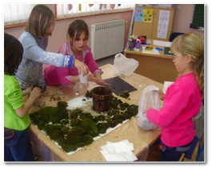
Image 18. Active participation of students in the lesson
Responses to the question posed in the questionnaire, which students filled out at the end of the study (Appendix 4), confirmed that the students were very active in the realization of their projects. All the students declared that they were fully active in the project. Nobody decided for quite a few other, negative, options.
For students, learning was a game. They often continued to learn and socialize even after school. However, some of the parents did not like that:
Some began to hang out more often at home, they didn't work but came to play. And then we had to send them home. In fact, they were not learning at that time. They want to learn if I was there, or other adults. I believe that was the case in other houses. But leave them alone ... I do not think so. They did not do a thing when they were on their own. However, I do not know how it in other houses, but here they played, turned the radio on ... Actually the real work lasted fifteen to twenty minutes, and they began playing (pupil's mother, P.L., personal communication, December 2005).
Satisfaction of the students grew as their freedom was increased. Students were free to choose themes and projects as a means of achieving them, began to freely use the Internet, while achieving project activities they were free to move around the classroom during class time, freely and openly they spoke to me for help, and were free to choose the manner of presentation of the projects. I found that the increased freedom of students and had a lesser need for a "sprint " out of the classroom as soon as recess began, and some continued their activities even then as noted in the discussion on the forum: "The most interesting to me was when I told to go to lunch and recess, and they did nothing! I again reiterated that they may go to recess, and they all said that they want more work and that they should not rest, in unison." ( Ljubac Mec, personal communication, 28 February 2006).
The results of the questionnaire confirm that the students were very free, relating to the internal (intrinsic) and external (extrinsic) motivation (Appendix 5). The results showed that most of the students were motivated in interior design classes that they enjoyed doing it (Image 19).

Image 19. The results of the questionnaire on students' motivation
The students' satisfaction in participating in projects is confirmed by the answers in the final questionnaire (Appendix 4). The majority of students were completely satisfied by participating in the projects while they were significantly fewer were less satisfied. No one showed complete dissatisfaction (Image 20).

Image 20. The students' satisfaction in project participation

Upon the completion of the project, students filled in questionnaires that were very easy to read. Assessment and other judgments referred to the satisfaction of our students, the previous teaching, the student projects and the teacher. On this occasion I used the semantic differential in which the students should opt for an association that relates to a specific term. For example, students had to circle one of two specific associations on the slip on which the word "teacher" was written. Basically they were offered two extremes, which we define as positive and negative, but they were mixed together (e.g., sweet-sour, friendly-hostile, bad-good ...).
Table 4. Semantic differential – ''Our previous method of teaching''
POSITIVE NEGATIVE
Bad | 91% |  |  |  |  | 9% | Good
Friendly | 9% | 91% |  |  |  |  | Hostile
Free | 100% |  |  |  |  |  | Constrained
Boring | 83% |  |  |  | 17% |  | Interesting
Important | 25% |  | 75% |  |  |  | Irrelevant
Cold | 75% |  |  | 25% |  |  | Warm
Sweet | 100% |  |  |  |  |  | Sour
Passive | 83% |  |  |  | 17% |  | Active
Closed | 91% |  |  |  |  | 9% | Open
Gentle | 9% | 91% |  |  |  |  | Harsh

It is noticeable in Table 4 that the students' negative associations in relation to the "old classes" dominate. In contrast with the classes in which students are engaged in projects which they generally link with positive associations (Table 5). Positive associations were almost entirely present in Table 6, which refers to the teacher.

Table 5. Semantic differential: Project method of teaching
POSITIVE NEGATIVE
Bad | 100% |  |  | Good
Friendly | 100% |  |  | Hostile
Free | 100% |  |  | Constrained
Boring | 9% | 91% |  | Interesting
Important | 91% |  | 9% | Irrelevant
Irrelevant | 100% |  |  | Warm
Sweet | 100% |  |  | Sour
Passive | 9% | 91% |  | Active
Closed | 9% | 91% |  | Open
Gentle | 91% |  | 9% | Harsh

Table 6. Semantic differential: The teacher
POSITIVE NEGATIVE
Bad | 100% |  |  | Good
Friendly | 100% |  |  | Hostile
Free | 100% |  |  | Constrained
Boring | 100% |  |  | Interesting
Important | 91% |  | 9% | Irrelevant
Cold | 100% |  |  | Warm
Sweet | 100% |  |  | Sweet
Passive | 9% | 91% |  | Active
Closed | 100% |  |  | Open
Gentle | 100% |  |  | Harsh

At the beginning, the collaboration between students was minimal. The only noticeable cooperation happened when we put them in pairs. During the realization of their projects, students increasingly collaborated within teams. They gradually cooperated more. Eventually, the students learnt the rules of conduct in the team, as well as the division of responsibilities within the team.
(GREAT/GOOD/BAD)
April 2005 / June 2005 / September 2006 / March 2006
Image 21. The increase in satisfaction from cooperation in teams during the research

As the research progressed, students felt better in teams, as evidenced by the results of evaluation sheets (Image 21) we conducted several times during the study. Students were asked to draw an appropriate emoticon that was best suited to the question "How did you feel in the team?" Along with emoticon stickers, the words great, good and bad were written.
In addition, some students who previously were not too prominent in the class, became respected colleagues within the team. Thus, a student who had been very withdrawn and rarely involved in communication and play with other children at the beginning of the study became highly respected for their IT capabilities that were particularly evident when editing a student magazine (Image 22).
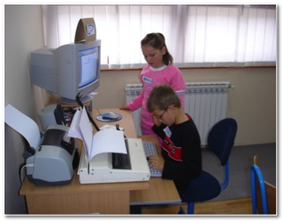
Image 22. Independent activities of students whilst making a magazine during class

The student who was initially quite dominant in the realization of cooperation is no longer trying to negotiate with the teachers but with the members of her team, and in the subsequent actions she took a constructive leading role. So in the ''Small printing house'' project she was the editor of the student magazine. Her organizational skills came to the fore which contributed to the successful realization of this project of which all the students were proud.
The changes were not made only in students, but also in me, as has been noted by Branko Bognar:
I have been cooperating with Danijela since she began working as a teacher at my old school and I really can say that the progress is visible, from uncertain teacher trainee to excellent teacher that I would gladly trust to be a teacher to my child. Danijela, you have a very rare combination of attributes, such as modesty, perseverance and willingness to learn. When the three merge, there are actually no big obstacles, unless modesty becomes a fear that can paralyze your actions. But in a safe and secure environment, like our own, I believe that there is no danger of that happening (Bognar, personal communication, January 13, 2006).

Engaging in action research particularly contributed to the process of improving practice. At first I tried to introduce changes, for which I did not systematically collect data, and so I did not publish the results of these efforts. However, in this study I started from the beginning with a systematic plan, but I also documented the changes achieved by using different data and feedback from students, parents and critical friends. I regularly recorded their experiences and feelings in a research journal in the Moodle system which teachers from several elementary schools participate in. In doing so, I used the suggestions of the project manager Branko Bognar who regularly responded to my, but also other, issues involved in the project.

What problems did I notice during the process of the research?
While I was at the beginning of the study, I was interested in improving my pedagogical practice, I did not know what I could change specifically. Of course, the effort of working in favor of showing that everything was right in my class wasn't good for that.
Basically, I was pleased with my students and teaching, but when I "scratched beneath the surface," I realized how much it could change. I was very thoughtful when our teacher Branko Bognar said, at a meeting of a learning community, that is impossible not to have problems in the classroom and that they exist within each of us, we just have to look at ourselves a little better. (Ljubac Mec, personal communication, December 2004).
The first problem I faced was the choice of topics/issues I would deal with. It was not easy to single out one particular problem. The next problem was the search for literature that would suit my theme. The participants of the Network Learning Communities project that had worked through the electronic system Moodle were of great help to me. When I studied the literature, it was interesting to translate new ideas into teaching practice. As time went on, the practice was becoming richer, but as the action research did not only deal with the introduction of changes in the educational process, but in trying to explore these changes, it was necessary to continuously collect data. It was often pointed out to me by Branko, who said that the research is not only conducting the educational activities, it only becomes the necessary high quality teaching practice if changes are documented.
Technical tools for collecting data play an important role. Sometimes, I missed the camera in the important moments so I could not document activities of the teaching process. Since I have not received any financial support for my research, apart from Applications which I forwarded to the Country Office of Education and Culture, (and even in school there was a greater understanding for the increased needs in the provision of technical aids) I had to get all the necessary equipment myself. So at the beginning of the project I bought a video camera and a digital camera and purchased a new computer. At first I encountered problems when using the computer but with the help of IT literate critical friends and my husband I mastered it.
Although I tried to plan the process of action research in detail, I soon noticed that it was not possible to do so. I could not predict the inclusion of students in the process of negotiation and planning their own projects. In addition, I could not predict all the problems I might encounter during the research so my plan was developed according to the needs and interests of students, but was also a reflection of the perceived problems in making changes.
At first I didn't refer to any literature because I did not fully understand the importance of theoretical assumptions. I shared this understanding with my colleague, who was also in doubt about the importance of theoretical assumptions in the process of action research:
Problems arose during the drafting of the report. Although I had collected a lot of data, I did not know how to handle, display and interpret it all and so it would resemble an action research report. Here, what helped me were tips from my mentor prof. Ana Sekulic Majurec as well as tips from Branko Bognar, who wrote the following on the forum:
Danijela, it is clear in your text that there are very interesting activities, that resulted in a multitude of life's details, happening in your class. Students are actively engaged in the realization of projects, editing the blog and my personal insight into your teaching career I have noticed great improvements. It's good to have some of the collected data "put on paper," but, at the same time you need to take into account the important details ...
Action research must have a clearly structured story that needs to be supported by the data, but not vice versa, when the data follows one's story. So, avoid disjointed listing of additional data (logs, photographs, interviews ...) which is incorporated in the text of the report. (B. Bognar, personal communication, January 13, 2006).
It is especially important, when making any statements, to overcome internal resistance, and also the fear of writing that was a heightened sense of lack of qualification for that activity. In addition to the advice of experts reading professional literature on the topic of research, but also on action research, have helped me.

Interpretation

The action research inquiry lasted almost two school years. At first I defined that the problem in this case was associated with a lack of autonomy in students. So I focused on replacing teaching aimed at teachers with teaching aimed at students. In doing so, I set the emphasis on discovery learning, which is based on the students' needs and interests. According to Bognar and Matijević (2002, p. 282) detection of learning strategies can be divided into methods of research, projects and simulations. In any case it is experiential learning as it comes to the knowledge -based activities and experiences of students. In this study, students chose projects that were related to their interests and experiences and they were engaged in the study of the living world and the everyday activities of people of the region they live in.
Based on the analysis of the initial recordings, it can be noted that the teaching was initially organized quite traditionally. At that time I was a young teacher with only a few years of work experience and I tended to comply with the methodological guidelines I had learned while studying. Although I was familiar with the idea and the basic principles of design methods, I did not know how to apply them. Instead, I settled for the solutions that had been well known, but at the same time did not match my original ideas. The discrepancy between the educational values ​​and what really happens in practice Whitehead (1989) called the living contradiction that needs to be eventually reduced or completely eliminated, with action research playing a particularly important role. This type of research allows practitioners to explore their practice - to observe, describe and explain what they are doing together with other members of the research (McNiff & Whitehead, 2006, p. 13). Unlike traditional instruction, in which teachers can also make changes, action research involves the publication of a report in which the process of improvement of practices is described and explained. During the study, but also when I became a teacher, I was able to find examples of action research that would help me in a different design for classes. I am hoping that the experiences presented in this study will help students and teachers in achieving substantial changes in their practice, but also that it will encourage them to engage in action research .
In planning the changes I used the literature which explains the features, describes the process and gives examples of the realization of the project method (Munjiza, Peko, Sablić, 2007, Helm and Katz, 2001, Katz & Chard, 2000). However, the achievement of learning projects in which the emphasis is on independence and in the activities means it is not good to stick to information from literature too rigidly. The activities should be adapted to the students' ideas and initiative. This means it is difficult to formulate projects in advance by methodical design scenarios instead, it is necessary to negotiate with students about the plan and the final performance of the whole process.
Students have time to accomplish more research projects which they themselves have chosen, which deal with what has contributed to their intrinsic motivation. Part of the project activities are exercised in the school within different subjects, especially during the teaching of science and society. However, some activities (e.g., watching animals and keeping notes about their behavior, feeding and features) are done at home. It is possible to conclude that in the student projects it is not enough to predict the time only in the framework of regular teaching activities, it is necessary to take into account the students' self-instigated involvement outside of school. This, of course, implies the absence or otherwise of devising homework that should become an integral part of students' own projects.
For pupils' successful engagement in project activities we need to anticipate and provide a variety of teaching resources and materials. As the school did not have everything I needed I often brought additional resources from the main school. In addition the students worked hard to obtain and bring everything they needed to carry out the planned project activities, and some sources they created themselves. Thus, amongst other things, the students edited journals in print and on the Internet. From this we can conclude that, in contrast to traditional teaching, in the design method students take responsibility for the planning and preparation of classes, which also contributes to their independence and activity.
Folders (portfolios) have proven to be an excellent opportunity for pupils' own collection of educational materials, notes and papers that have emerged during the implementation of projects. Initially, some students were very insecure when editing their folder. They did not know if what they had prepared would be good enough and should have been placed in a folder instead. I got the impression that only very confident students filled the folders in. Then I began to praise and encourage every step made by the ​​more uncertain students. In addition, students especially liked it when they were pasted personal photographs in the folder. All this has contributed to the increase in number of reports in their respective folders.
Although the students had the opportunity to inspect each other's folders, I mostly did it myself. Some students, especially those who were less expressive in writing, asked me to stay after school or during recess in order to read the written works. I noticed that as a way of cooperation, staying after school became a more frequent occurrence. It seemed to me that the students corresponded to get as much of my attention and affection. As if it additionally motivated them to edit their maps. Based on the notes and materials from the folders, the students put together shorter texts that were then published on the class of e-journal BETUREL. In particular, they rejoiced upon reading comments from readers, some of whom lived outside their village.
In the realization of the project method, the classroom space is insufficient to meet the students' increased educational interests. Therefore, in almost every part of the project, activities were accomplished outside the classroom. Each group agreed what they will deal with. Together they collected information about healthy eating, visited the bakery, the dairy, the store, talked to the experts and other people in their environment, and upon returning to school used the information gathered and dealt with the new tasks. Whilst participating in classroom activities students were very active and full of impressions, full of questions and suggestions, and had lots to talk about. It was important to the students that they visited other facilities, institutions and the like. In this way, they opened up new educational horizons, devised new and original ideas, and did not merely rely on what the teacher told them. Instead of the natural and social amenities students learnt from books or other sources, especially electronic resources, they had the opportunity to learn through observation and participation in genuine-activities. In this way those facilities became more substantial and meaningful. However, it would be wrong to conclude that the classroom activities contributed to the reduced interest in the written sources. Indeed, after visiting and talking with the experts, the would often resort to using illustrated encyclopedias, magazines and the Internet.
Students were happy to discuss with experts during the realization of their projects, and this was particularly evident when we visited the weather station. However, it turned out to be a good idea to talk with the experts / guides before the visit, and explains the extent to which they would be able to go in talking to students. It turned out that some explanation was too technical and some of the students immediately gave up any attempt to ask questions or engage in debate.
In the photographs and videos it is possible to see the frequent changes in the distribution of seats, which are adjusted to the used teaching forms. However, the students did not participate in class just sitting. Very often the teaching activity occurred in different parts of the classroom and on the carpet (Image 23), which was located in the middle or in another part of the room. We can conclude that in the project method there is no way of perfectly decorating the classrooms. Moreover, decorating the classroom is the subject of an agreement with the students.

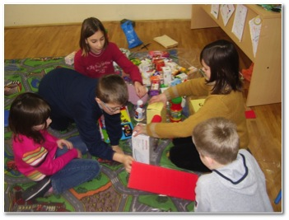
Image 23. The students' activity on the carpet
Collaborative learning in which students achieve the agreed activities in groups is of particular importance for the design method. It encourages positive interdependence and individual responsibility for their own learning and active participation in problem solving. Klippert points out that cooperative learning is not achieved just by sitting students down in groups, but it "requires the ability and readiness for action and cooperation." This form of teaching "requires that students are thoroughly familiar with the objectives and rules for group work, and realize that the work in group makes sense..." (Klippert, 2001, p. 30). In the initial phase of the study, students generally realized their projects individually, but when I introduced collaborative tasks, there was a problem of insufficient or poor cooperation within teams. This problem can be partly explained by the developmental level of seven-year-old and eight-year-old students who according to Piaget (1988) find the transition from the preoperational stage of concrete operations for which it was specific that children can work together because we did not confuse personal point of view with the view of others.
That's why I sought to mix boys and girls to share their knowledge and create better relationships. However, in the last project I let the students create groups according to their choice. It happened to be that in one team there were only boys because they really wanted it that way. It turned out that these boys had equal interests, desires, goals, and they then more easily achieved and they are arranged within the team better. We can conclude that the conduct of the teaching process should take into account the recommendations cited in the literature, but they should not be literally hold. Teaching is a creative process in which a teacher should always listen to the needs and interests of their students and consequently make decisions about how to organize certain activities. In order to know what the students respond, it is good to try different solutions and one of them is to ask for feedback.
Students individually elected members of teams and tasks. They identified specific roles within teams. This proved to be successful because it is only then that every student became aware that he is responsible for his actions. Previously, some students thought that "someone has to do the task for them". From the collected materials they produced magazines, and in the end they all came together in a harmonious and aesthetically beautiful shaped unit, which they called "The house of flowers with trees and magic mushrooms". In this case, students have received recognition from me that I expressed in the following words: "Great! I cannot believe how you dealt with horticulture today". The award was created. Specifically, in a video (http://vimeo.com/2722890) and photographs (Image 2.) it is possible to observe the pride and joy of students in preparation and finalization of the model house surrounded by plants and floral arrangements.

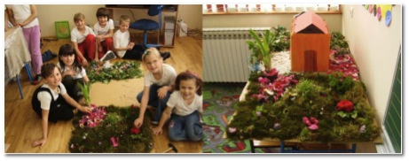

Image 24. Students make a scale model of a house with flowers
When realizing the project method, it is good to take into account the multiple intelligence (Gardner, 1993) of students, and identify their strengths and highlight them in front of everyone. This is especially important for students of lower confidence. It is also important to recognize the dominant pupils and suitably employ them. For example, in the "small printing house", a student, who had emphasized the need for domination which had a negative effect on cooperation within the team, and is very capable of performing various operations, was appointed to be the editor of the newspaper. Coordinating different groups - journalists, illustrators and print preparation - she was fortunate to have such an important function. At the same time she satisfied her need for cooperation, organization and conduct of operations. Other students did not complain because she fulfilled the tasks that belong to the role of a newspaper editor. We conclude that for the successful organization of project activities and cooperative learning, the teacher takes a good knowledge of students in order to minimize their weaknesses, and gives them the affirmation of positive possibilities.
To enable equal participation of students can be crucial for the development of their social skills, especially if they themselves are not inclined to fight for it. We know that some people have no compunction to stand in a group and speak publicly, while for others it is extremely difficult. In schools learning is taken for granted and not just about facts. Children are expected to express themselves fluently, as well as discuss, collaborate and listen carefully. And teachers are expected to teach. Although it is meant to be taught in school, it is questionable how systematically and deliberately we are truly working on the development of these and other social skills. Frequent use of cooperative learning can significantly contribute to the development of social skills, independence and pupil activities.
In the final project, the students are part of a larger project activity exercised at home so I had no insight into their activities. I prepared forms through which they reported on what they did every day. In this way I received enough information about the student team activities. Apart from that I realized the importance of student goal-setting and detailed planning of project activities within the teams. At first I doubted whether small students could individually set goals and plan activities in writing. However, I soon realized that it was not a problem to students. Students successfully formed the basis of their interests and abilities. I conclude that it is not good to underestimate students' capabilities. Specifically, in teaching, in which the proceeds of student activities and independence often pleasantly surprised teachers.
By accompanying the students in realizing their projects, I got the impression that I was sometimes superfluous in the classroom and it seemed to me that students were so good at coping in this attempt to play the teacher's role that after the first ten minutes I was no longer essential. Sometimes it is enough to be in the role of an attentive observer, trying to spot what would be the next organization of learning activities that could be improved. Montessori (1949, p. 404) points out that the best sign of success is when the teacher can say, "The children are now working as if I did not exist." During this investigation it happened just that students are largely taken over by the responsibility for the learning process which only confirms the effectiveness of the design methods, but also the realization of the initial value on which this research is based.
The achievement of student projects included the parents. Most often their role was merely to provide information on topics with which the students engaged. Besides, the feedback of parents was important in monitoring changes achieved during the study. This was especially the expression in an interview conducted. Here are some of the parents' comments on the use of the project method in teaching:
Parent 1: I think it's very good. Yes it really develops children's imagination and creativity and altogether it's great.
Parent 2: Here, for example, last night, from nature, those three to four birds were in her book. Two of them she recognized, but she was not sure about the other two. I said, let me see them, and she said: "No, I've seen these birds in my sister's magazine," and she went, and found the pictures. Something she never would have before, she would sit and wait to tell her this and that. Now she would sit and flip through everything to find something related to the project.
Parent 3: Good. She was happy and when she went somewhere and when her team came here. It would be all prepared, papers, crayons, pens, encyclopedia, fun facts, they were already working. (parents of students, personal communication, November 2006).
Parents usually noticed some positive changes in their children. However, some problems have been reported regarding student engagement in project activities at home where the children were, in the opinion of two mothers, rather having fun than studying:
Teacher: How do they behave when working in a team with you at home?
Mother: Well, to me they must be good.
Teacher: What does that mean?
Mother: Well, because they tried to go wild ... made mistakes, crumpled up the paper, threw paper at each other, and later were able to throw the ashtray. There were five, six of them then.
Teacher: Did you feel as if they were working?
Mother: Yes, I cannot tell you, they work, they write and copy ... I think that the time they wrote about mushrooms ... but I'm not up for them to work at home. Maybe, but with the presence of somebody older. But now, when I go out to hang laundry and hear ha, ha, ha ... squeals, screams, I think what you're doing? (Interview with mother V. M., personal communication, November 2006).
Two mothers interviewed agreed that there were problems during the learning at home, but for the third mother it was not a problem:
They're usually in the room, and as I noted, I knew when I entered, just to ask them something and so that's a bit ... and they have already divided themselves by who the best artist is, who will be best to write something ... So they are not looking for anyone. They took out the fun facts, old magazines, this or that all of which they found themselves. Throughout the game, there was laughter, games, normally, but nothing bad. If they were there an hour, for half an hour they were playing, but for half an hour they did something. (Mother I.Đ., personal communication, November 2006).

Based on previous feedback from parents, we can conclude that there are certain problems in the student's self- realization of the project activities at home, but their cause must be sought not only in the behavior of children, but also in the expectations of parents. Specifically, there is a strong possibility that parents were not sufficiently sensitive to the new approach to learning. Therefore, it would be good at times to call parents and inform them about the specifics of the project and the methods in which all students are engaged. It is also advisable to talk about their experiences at home and together with them to try to identify problems and devise appropriate responses to them.
I came to the conclusion that the application of design methods can happen at stage-changes in teaching. These changes are related to the structure of the teaching process, which in this case consisted of the arrangements of the different stages, implementation and evaluation. In all these stages, the emphasis is placed on students' independence, quality of activity and collaboration. In addition, the relationship between students and teachers has become a partnership. If students have confidence in their teachers, if their communication is supportive then students will be more open to collaboration, but also more willing to be accountable for their work. If students are under pressure and have the feeling that something must be done because of grades or punishment, then the intrinsic motivation underlying the project method will falter. When I listen to the students, their thinking, when you follow their eyes, smiles, posture, when I take into account general non-verbal communication, it has already created a basic prerequisite for progress and success. I realized that teachers sometimes do not have enough confidence in their students. They find that they must "keep all the strings in his hands." Our teaching is just proof that when the students came up with an open heart, and when they were given the trust can arise wonderful works.

References

Ajduković, M., & Kolesarić, V. (2003). Etički kodeks istraživanja s djecom. Zagreb: Vijeće za djecu Vlade Republike Hrvatske, Državni zavod za zaštitu obitelji, materinstva i mladeži.
Amabile, T. M. (1989). Growing up creative: Nurturing a lifetime of creativity. New York: Crown Publishers.
Amabile, T. M. (1996). Creativity in context. Boulder: Westview Press.
Anić, V. (1991). Rječnik hrvatskoga jezika. Zagreb: Novi Liber.
Argyris, C., & Schön, D. A. (1978). Organizational learning: A theory of active perspective. Reading; Menlo Park; London; Amsterdam; Don Mills; Sydney: Addison-Wesley Publishing Company.
Bake, J.-I. (2006). The Projectile Method (Die Projektmethode). Norderstedt: GRIN Verlag.
Bognar, B. (2006a). Akcijska istraživanja u školi. Odgojne znanosti, 13(1), str. 209-227.
Bognar, B. (2006b). Kako procijeniti kvalitetu akcijskog istraživanja. Metodički ogledi, 13(1), str. 49-66.
Bognar, B. (2008). Mogućnost ostvarivanja uloge učitelja – akcijskog istraživača posredstvom elektroničkog učenja. Zagreb: B. Bognar.
Bognar, B. (2008). Stvaralački pristup znanosti. Metodički ogledi, 15(1), str. 11-30.
Bognar, L., & Matijević, M. (2002). Didaktika. Zagreb: Školska knjiga.
Dewey, J. (1910). How we think. Boston; New York; Chicago: D. C. Heath & Co.
Dewey, J. (1997). Experience and education. New York: Touchstone.
Dewey, J. (2004). Democracy and education: An introduction to the philosophy of education. Delhi: Aakar Books.
Dryden, G. (2001). Revolucija u učenju: Kako promijeniti način na koji svijet uči. Zagreb: Educa.
Gardner, H. (1993). Frames of mind: The theory of multiple intelligences. London: Fontana Press.
Glasser, W. (1994). Kvalitetna škola: Škola bez prisile. Zagreb: Educa.
Glasser, W. (1999). Nastavnik u kvalitetnoj školi: Posebne sugestije nastavnicima koji u razredu pokušavaju primijeniti ideje iz knjige Kvalitetna škola . Zagreb: Educa.
Grotewell, P. G., & Burton, Y. R. (2008). Early childhood education: Issues and developments. New York: Nova Science Publishers.
Helm, J. H., & Katz, L. G. (2001). Young investigators: The projectile approach in early years. New York; London: Teachers College, Columbia University.
Johnson, D. W., Johnson, R. T., & Johnson Holubec, E. (1993). Circles of learning: Cooperation in the classroom. Edina: Interactive Book Company.
Katz, L. G., & Chard, S. C. (2000). Engaging children's minds: The projectile approach. Stamford: Ablex Publishing Corporation.
Kauchak, D. P., & Eggen, P. D. (1998). Learning and teaching: Research-based methods. Needham Heights: Allyn and Bacon.
Kilpatrick, W. H. (1929). The projectile method: The use of the purposeful act in the educative process. New York: Teachers College, Columbia University.
Klippert, H. (2001). Kako uspješno učiti u timu: Zbirka praktičnih primjera . Zagreb: Educa.
Koraj, Z. (1990). Osposobljavanje učenika za samostalno učenje. 45(1), str. 46-52.
La Marca, S. (2010). Designing the learning environment: Learning in a changing world. Camberwell: ACER Press.
Lesourne, J. (1993). Obrazovanje & društvo: Izazovi 2000. godine . Zagreb: Educa.
Lomax, P., Woodward, C., & Parker, Z. (1996). How can we help educational managers establish and implement effective ‘critical’ friendships? U P. Lomax (Ur.), Quality management in education (str. 151-165). London; New York: Hyde Publications.
Marx, K. (1989). Prilog kritici nacionalne ekonomije. U K. Marx, & F. Engels, Rani radovi. Zagreb: Naprijed.
Marzano, R. J., Pickering, D. J., & Pollock, J. E. (2006). Nastavne strategije: Kako primijeniti devet najuspješnijih nastavnih strategija. Zagreb: Educa.
McNiff, J., & Whitehead, J. (2002). Action research: Principles and practice . London; New York: Routledge/Falmer.
McNiff, J., & Whitehead, J. (2006). All you need to know about action research. London; Thousand Oaks; New Delhi: SAGE.
McNiff, J., & Whitehead, J. (2009). Doing and writing action research. London; New Delhi; Singapore; Washington: SAGE.
McNiff, J., & Whitehead, J. (2010). You and your action research projectile. London; New York: Routledge.
Miles, G. E. (2000). Action research: A guide for the teacher researcher. Upper Saddle River: Prentice-Hall, Inc.
Montessori, M. (1949). The absorbent mind. Adyar; Madras: The theosophical publishing house.
Montessori, M. (2004). The secret of childhood. Chennai: Orient Longman Private Limited.
Munjiza, E., Peko, A., & Sablić, M. (2007). Projektno učenje. Osijek: Sveučilište J. J. Strossmayera, Filozofski fakultet u Osijeku i Učiteljski fakultet u Osijeku.
Mužić, V. (1999). Uvod u metodologiju istraživanja odgoja i obrazovanja. Zagreb: Educa.
Palekčić, M. (2002). Konstruktivizam - nova paradigma u pedagogiji? Napredak, 143(4), str. 403-413.
Peko, A., & Borić, E. (2001). Projektna metoda u nastavi. U M. Kramar, & M. Duh (Ur.), Didaktični in metodični vidiki prenove in razvoja izobraževanja : zbornik povzetkov 2. mednarodnega znanstvenega posveta (Maribor, 22. i 23. studenog 2001.) (str. 79-85). Maribor: Pedagoška fakulteta, Oddelek za pedagogiko, didaktiko in psihologijo.
Peko, A., Munjiza, E., & Sablić, M. (2006). Poticanje aktivnosti učenika projektnom nastavom. Napredak, 147(4), str. 492-502.
Pilić, Š., & Tomaš, A. (1994). Neke odrednice osamostaljivanja odgajanika. Školski vjesnik, 43(2), str. 163-172.
Poljak, V. (1965). Cjelovitost nastave, didaktički problem reforme škole. Zagreb: Školska knjiga.
Ridenour, C. S., & Newman, I. (2008). Mixed methods research: Exploring the interactive continuum. Carbondale: Southern Illinois University Press.
Rogers, C. (1985). Kako postati ličnost. Beograd: Nolit.
Ryan, K., Cooper, J. M., & Tauer, S. (2013). Teaching for student learning: Becoming a master teacher. Belmont: Cengage Learning.
Sekulić Majurec, A. (1994). Akcijska istraživanja u praksi školskog pedagoga. U H. Vrgoč (Ur.), Iz prakse pedagoga (str. 9-16). Zagreb: HPKZ.
Sekulić Majurec, A., & Cvetković Lay, J. (1998). Darovito je, što ću s njim. Zagreb: Alinea.
Slavin, R. E. (2006). Educational psychology: Theory and practice. Boston; New York; San Francisco; Montreal; London; Madrid; Münich; Paris, Hong Kong; Singapore; Tokyo; Cape Town; Sydney: Pearson Education.
Sternberg, R. J., & Williams, W. M. (1996). How to develop student creativity. Alexandria: ASCD.
Stiggins, R. J. (1997). Student-centered classroom assessment. Upper Saddle River; Columbus: Merill.
Španović, S. (2002). Uloga i značaj portfolija u sistemu vrednovanja u nastavi. Norma, 8(3), str. 45-57.
Terhart, E. (2001). Metode poučavanja i učenja: Uvod u probleme metodičke organizacije poučavanja i učenja. Zagreb: Educa.
Whitehead, J. (1989). Creating a living educational theory from questions of the kind, "How do I improve my practice?". Cambridge Journal of Education, 1, str. 41-52.
Whitehead, J., & McNiff, J. (2006). Action research living theory. London; Thousand Oaks; New Delhi: SAGE.

Appendix 1: The initial questionnaire for students

THE INITIAL QUESTIONNAIRE FOR STUDENTS

NAME OF SCHOOL:_____________ TOWN: ________________

DATE OF TAKING THE QUESTIONNAIRE:_________________________

Note: Read the question carefully and choose an answer.

- Do you want to participate in research in school?

YES NO

- Within which subject do you want to carry the research out?

  - Croatian language
  - math
  - nature and society

- State what would you like to research in this subject?
_______________________________________________________

- State ways in which you could accomplish this.
_______________________________________________________
_______________________________________________________

- Do you believe you learn independently at school?
YES NO

- Do you cooperate with your colleagues often?

YES NO

- Are you happy with the way the school works now?

YES NO

Appendix 2: Initial questionnaire for parents

INITIAL QUESTIONNAIRE FOR PARENTS

NAME OF SCHOOL:________________ TOWN:________________

DATE:________________________

Note: The purpose of this questionnaire is to determine independently the choices, cooperation and commitment of your child. The questionnaire is anonymous so please be honest and answer the questions based on observations of your child. There is no right or wrong answers, and the purpose is to analyze the situation. Thank you in advance for your cooperation.

Read the question and circle one of the possible answers YES or NO.

- Do you think your child is independent enough?? YES NO

- Does your child have the right to choose things a school? YES NO

- Does your child cooperate with others? YES NO

- Is your child busy with homework at home? YES NO

Appendix 3: Student questionnaire
STUDENT QUESTIONNAIRE

NAME OF SCHOOL:_____________ TOWN: ________________

DATE:________________________

Note: Read the questions carefully and circle an answer.

- Are you happy with the research we carry out?

YES NO

- Circle a number of 1 to 5 related how much you like the research.

Not at all 1 2 3 4 5 A lot

- Has the research made you more independent?

YES NO

- Were you active in the research?

YES NO

- Circle what sources you used in the research:

  - The Internet
  - Encyclopedias
  - Professional and other magazines
  - talking with experts
  - observing the environment (genuine milieu).

- Circle how much you cooperated with colleagues.

  - not at all
  - a little
  - a lot.

- How much do you like working in teams? (Circle a number from 1 to 5.)

Not at all 1 2 3 4 5 A lot

- Did you freely settle on a topic in a team?

YES NO

- Do you study more at school and at home now?

YES NO

- Do you want to keep participating in these projects?

YES NO

Appendix 4: Final student questionnaire
FINAL STUDENT QUESTIONNAIRE

- Circle how pleased you are with cooperation in teams!
  - completely
  - barely
  - not at all

- Circle how active you were in the team!
  - completely
  - barely
  - not at all

- Circle how much of the tasks you did without help from the teacher!
  - completely
  - barely
  - not at all

- Circle how happy you are with the projects!
  - completely
  - barely
  - not at all

- Circle everything you like about school!
  - Seating arrangements
  - Participation in projects
  - Copying from the board
  - Reading a book
  - research
  - editing the blog
  - studying in teams
  - freedom
  - independence
  - tests
  - playtime
  - solving tasks from the workbook

Appendix 5: The students' motivation survey
THE STUDENTS' MOTIVATION SURVEY
Name:________________ Date:_____________________
- I |  | I had to talk my parents into letting me work on these projects.
- E |  | I think a lot about the good things that my parents or a teacher will say when dealing with projects.
- I |  | When I work on projects, I feel as if I'm learning what I want to learn.
- I |  | When I am given the opportunity to choose between multiple things to do, I always choose a project.
- E |  | I want my parents and teachers to know how good I can be in dealing with these projects.
- I |  | I work on projects because it really interests me.
- E |  | I hope to make a lot of money working on similar projects.
- E |  | I like to do these projects while being observed.
- I |  | The more challenging the project, the more I enjoy it.
- E |  | I work on projects because my parents or teachers have told me I have a feel for it.
- I |  | I really enjoy seeing what I've done whilst working on projects.
- E |  | I mainly work on projects because my parents or teachers ask me to.
- I |  | I like to think of new things when I work on projects.
- E |  | When working on a project, I often wonder what others would say about it.
- I |  | To me, the project is more of a game than work.
- I |  | Sometimes when I deal with projects I forget everything else.
- E |  | I believe that there is no point in working on a project if no one is there to see it.
- I |  | I feel really good when I know I'm doing a good job on the project.
- E |  | I spend a lot of the time working on projects and I feel I don't like it.
- I |  | When I work on projects, I like to decide what I will do for myself.
- E |  | I like it when someone leads me to the goal.
- I |  | I would be really disappointed if I could no longer participate in projects.
- E |  | I work on projects because other has told me that I am really good at it.
- I |  | I have quite a lot of fun while doing projects.
- E |  | I like a project most when I can accomplish it easily.
- I |  | Sometimes I lose track of time while working on a project.
- E |  | I really enjoy being better than others when I work on projects.
- E |  | If I did not have to, I would not work on projects.
- E |  | I hope to be renowned one day for working on projects.
- I |  | I discover new things about myself when dealing with projects.
- E |  | I really like receiving gifts and prizes when doing projects.
- I |  | The projects are important to me.

Motivation/questions
Inner (intrinsic)
Outer (extrinsic)
Motivation/questions
Inner (intrinsic)
Outer (extrinsic)

Taken from Amabila (1989, str. 65-67). Translated and adapted by B. Bognar.

